PL/SQL ASSIGNMENT_2
Name: MUTANGANA Joseph ID: 29061 ASSIGNMENT2 REPORT
Course Code and Name: INSY 8311 – Database Development with PL/SQL

TASK A: SQL Recap
A1. (a): Query
SET SERVEROUTPUT ON
select d.department_name, d.location, nvl(count(e.employee_id),0) as number_of_employees,
nvl(sum(e.salary),0) as total_salary_bill,
round(nvl(avg(e.salary),0), 2) as average_salary, (select nvl(count(c.course_id),0) from courses c where c.department = d.department_name) as total_courses
from departments d
left join
employees e on e.department = d.department_name
group by d.department_name, d.location
order by nvl(sum(e.salary),0) desc ;

Output
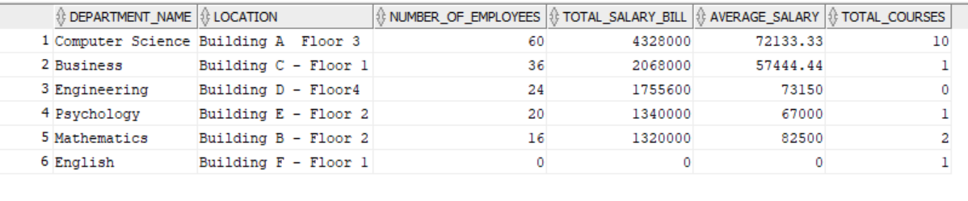
A1. (b): Query
SET SERVEROUTPUT ON
select d.department_name, d.budget, (select sum(e.salary) from employees e where e.department = d.department_name) as total_salary_bill,
(select sum(e.salary) from employees e where e.department = d.department_name)- d.budget as Amount_over_budget
from departments d
group by d.department_name, d.budget
having (select sum(e.salary) from employees e where e.department = d.department_name) > d.budget ;

Output
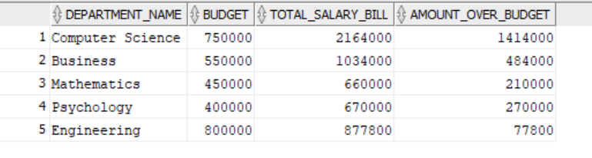

TASK B: Variables, %TYPE, %ROWTYPE and DBMS_OUTPUT
B1: Query
set SERVEROUTPUT on

declare
v_c_name varchar2(100) :='PL/SQL Programming';
v_cr number(1) :=3;
v_date date :=date'2024-09-01';
is_heavy boolean :=TRUE;
v_check varchar2(5);

begin
dbms_output.put_line('Course: '||v_c_name);
dbms_output.put_line('Credits: '||v_cr);
dbms_output.put_line('Semester Start: '||v_date);

if v_cr >=3 then
is_heavy := TRUE;
v_check :='TRUE';
else
is_heavy := FALSE;
v_check :='FALSE';
end if;
dbms_output.put_line('Heavy Course: ' || v_check);

end;
/
Output
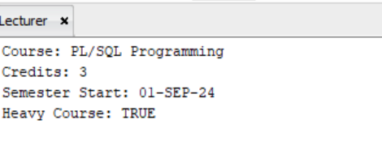
B2: Query
set SERVEROUTPUT on

declare
v_course_id number :=110;
v_course_name courses.course_name%TYPE;
v_cr courses.credits%TYPE;
v_instructor courses.instructor%TYPE;
v_max courses.max_students%TYPE;

begin
select course_name,credits, instructor, max_students into
v_course_name,v_cr, v_instructor, v_max
from courses where course_id = v_course_id;

dbms_output.put_line('Course Name: '||v_course_name);
dbms_output.put_line('Credits: '||v_cr);
dbms_output.put_line('Instructor: '||v_instructor);
dbms_output.put_line('Max_students: '||v_max);
if v_max <=25 then
dbms_output.put_line('Limited seats available!');
end if;
end;
/

Output
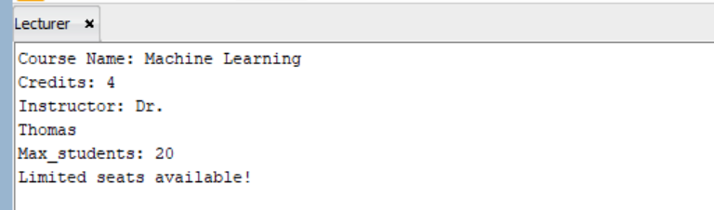

B3: Query
set SERVEROUTPUT on

declare
v_employee employees%ROWTYPE;
v_hire_year NUMBER;
v_years_worked NUMBER;

begin
select * into v_employee from employees where employee_id = 22;
v_hire_year := extract(year from v_employee.hire_date);
v_years_worked := trunc(months_between(sysdate, v_employee.hire_date) / 12);
dbms_output.put_line('Full Name: '||v_employee.first_name || ' ' || v_employee.last_name);
dbms_output.put_line('Department: '||v_employee.department);
dbms_output.put_line('Salary: '||v_employee.salary);
dbms_output.put_line('Hire Year: '||v_hire_year);
dbms_output.put_line('Years Worked: '||v_years_worked);
end;
/

Output
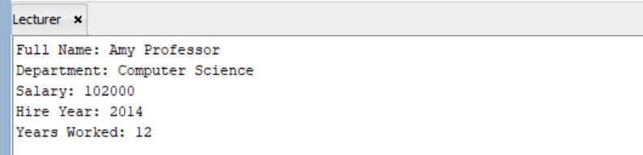

TASK C: IF / ELSIF / ELSE Conditions
C1: Query
declare

v_employee_id number :=1;
v_commission_pct number;
v_salary number;
v_potential_earning number;

begin
select commission_pct, salary into v_commission_pct, v_salary
from employees where employee_id = v_employee_id;

if v_commission_pct is not NULL and v_salary >80000 then
dbms_output.put_line('High-value manager with commission');
elsif v_commission_pct is not NULL and v_salary <=80000 then
dbms_output.put_line('Manager with commission, standard
tier');
elsif v_commission_pct is NULL and v_salary >90000 then
dbms_output.put_line('Senior employee, consider adding a
commission incentive');
else
dbms_output.put_line('Standard employee profile');
end if;
v_potential_earning := v_salary + (v_salary * NVL(v_commission_pct, 0));
dbms_output.put_line('Total potential earnings: '|| v_potential_earning);

EXCEPTION
when no_data_found then
dbms_output.put_line('No data found matching the '|| v_employee_id);

when others then
dbms_output.put_line('Unexpected error');

end;
/

Output
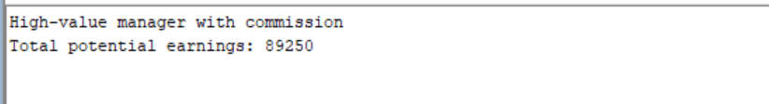

C2: Query
declare

v_course_id number :=103;
v_c_name varchar2(50);
v_enrolled number;
v_max_students number;
v_availability_status varchar(100);

begin
select count(*) into v_enrolled from enrollments
where course_id = v_course_id;

select course_name, max_students into v_c_name, v_max_students from courses
where course_id = v_course_id;

dbms_output.put_line('Course Name: '|| v_c_name);
dbms_output.put_line('Maximum Capacity: '|| v_max_students);
dbms_output.put_line('Current Enrollment: '|| v_enrolled);
if v_enrolled < (v_max_students * 0.5) then
v_availability_status :='Open, plenty of seats available';

elsif v_enrolled BETWEEN (v_max_students * 0.5) and (v_max_students * 0.8)then
v_availability_status :='Filling up, limited seats';

elsif v_enrolled > (v_max_students * 0.8) and v_enrolled < v_max_students then

v_availability_status :='Almost full, enroll soon';

elsif v_enrolled >= v_max_students then
v_availability_status :='FULL, enrollment closed';
end if;
dbms_output.put_line('Availability Status: '||v_availability_status);

EXCEPTION
when no_data_found then
dbms_output.put_line('No data found matching the '|| v_course_id);

when others then
dbms_output.put_line('Unexpected error');

end;
/

Output
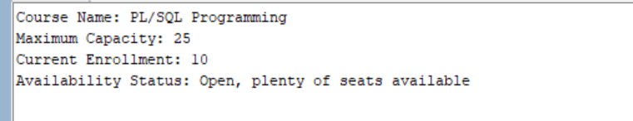

C3: Query
declare

v_student_id number :=1020;
v_dob date;
v_years number;
v_age number;
v_enrollment_date date;
v_enrollment_year number;

begin
select date_of_birth, enrollment_date into v_dob, v_enrollment_date
from students
where student_id = v_student_id;

v_years := trunc(months_between(sysdate, v_dob) / 12);
v_enrollment_year := extract(year from v_enrollment_date);

if v_years <18 then
dbms_output.put_line('Minor student, parental consent required');
elsif v_years >=18 and v_years <=25 then
dbms_output.put_line('Traditional student age');
elsif v_years > 25 then
dbms_output.put_line('Mature student, eligible for the evening program');
end if;

if v_enrollment_year = 2023 then
dbms_output.put_line('First-year cohort (2023)');
else
dbms_output.put_line('Joined in ['||v_enrollment_year||']');
end if;
EXCEPTION
when no_data_found then
dbms_output.put_line('No data found matching the '|| v_student_id);

when others then
dbms_output.put_line('Unexpected error');

end;
/

Output
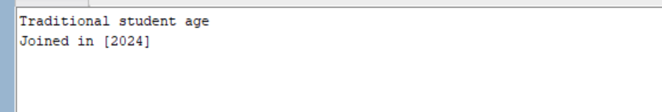

Section D: CASE Statements and Expressions
D1: Query
SET SERVEROUTPUT ON

declare

v_enrollment_id number :=5;
v_grade varchar2(25);
v_stored_grade varchar2(25);
v_score number;

begin
select score, grade into v_score, v_stored_grade from enrollments
where enrollment_id = v_enrollment_id;

case
when v_score is null then
v_grade := 'Not yet graded';
when v_score >= 90 then
v_grade := 'A';
when v_score >= 80 then
v_grade := 'B';
when v_score >= 70 then
v_grade := 'C';
when v_score >= 60 then
v_grade := 'D';
else
v_grade := 'F';
end case;

if v_grade = v_stored_grade then
dbms_output.put_line('Grade match: YES');
else
dbms_output.put_line(
'Grade match: NO (stored ' || v_stored_grade ||
', computed ' || v_grade || ')'
);
end if;

EXCEPTION

when no_data_found then
dbms_output.put_line('No data found matching the '|| v_enrollment_id);
when others then
dbms_output.put_line('Unexpected error');

end;
/

Output
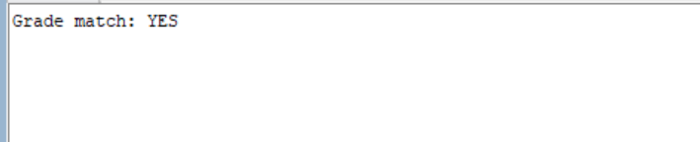

D2: Query
SET SERVEROUTPUT ON

declare

v_department varchar2(100) := 'Computer Science';
v_dep_id number :=10;
v_building_code varchar2(50);
v_budget number;
v_budget_status varchar2(50);

begin
select department_name, budget into v_department, v_budget from departments
where department_id = v_dep_id;

case
when v_department = 'Computer Science' then
v_building_code := 'BLD-CS | ICT Wing';

when v_department = 'Mathematics' then
v_building_code := 'BLD-MT | Science Wing';
when v_department = 'Business' then
v_building_code := 'BLD-BS | Commerce Wing';
when v_department = 'Engineering' then
v_building_code := 'BLD-EN | Technical Wing';
when v_department = 'Psychology' then
v_building_code := 'BLD-PS | Humanities Wing';
else
v_building_code := 'BLD-GN | General Wing';
end case;

v_budget_status := CASE
WHEN v_budget > 600000 THEN 'Well Funded'
WHEN v_budget >= 400000 THEN 'Adequately Funded'
ELSE 'Underfunded'
END;
dbms_output.put_line('Building Code: '||v_building_code);
dbms_output.put_line('Budget Status: '||v_budget_status);

EXCEPTION

when no_data_found then
dbms_output.put_line('No data found matching the '|| v_department);
when others then
dbms_output.put_line('Unexpected error');

end;
/

Output


D3: Query
SET SERVEROUTPUT ON

declare

v_emp_id number :=14;
v_name varchar2(50);
V_salary number;
v_job_title varchar2(50);
v_rank number;
v_rank_title varchar2(50);

begin
select first_name||' '|| last_name, salary, job_title into v_name, v_salary, v_job_title from employees
where employee_id = v_emp_id;

case
when v_job_title = 'Full Professor' then
v_rank :=1;
v_rank_title := 'Senior Academic';

when v_job_title = 'Associate Professor' then
v_rank :=2;
v_rank_title := 'Mid Academic';
when v_job_title = 'Assistant Professor' then
v_rank :=3;
v_rank_title := 'Junior Academic';
when v_job_title like '%Developer%' or v_job_title like '%Engineer%' then
v_rank :=4;
v_rank_title := 'Technical Staff';
when v_job_title like '%Admin%' or v_job_title like '%Coordinator%' then
v_rank :=5;
v_rank_title := 'Administrative Staff';
else
v_rank :=6;
v_rank_title := 'General Staff';
end case;

dbms_output.put_line('Name: '|| v_name);
dbms_output.put_line('Job Title: '|| v_job_title);
dbms_output.put_line('Rank Number: '|| v_rank);
dbms_output.put_line('Rank Title: '|| v_rank_title);
dbms_output.put_line('Salary: '|| v_salary);

if v_rank <= 2 and v_salary < 100000 then
dbms_output.put_line('Promotion eligible');
else
dbms_output.put_line('Not eligible for promotion yet');
end if;

EXCEPTION

when no_data_found then
dbms_output.put_line('No data found matching the '|| v_emp_id);
when others then
dbms_output.put_line('Unexpected error');

end;
/

Output

Section E: Loops

E1: Query
SET SERVEROUTPUT ON
DECLARE

v_tuition number :=150000;
v_c_name VARCHAR2(100);
v_c_cr NUMBER;
v_c_id number :=101;
v_total_cr number :=0;
v_frw number;
v_total_frw number :=0;
v_avg_cost number;

begin

loop

select course_name, credits into v_c_name, v_c_cr
from courses where course_id = v_c_id;
v_c_id := v_c_id +1;
v_total_cr := v_total_cr + v_c_cr;
v_frw := v_c_cr * v_tuition;
v_total_frw :=v_total_frw + v_frw;

dbms_output.put_line(rpad('Added: '||v_c_name,20)||' ('||v_c_cr||') |' || rpad(' Total: '||v_total_cr,10)||' credits | RWF '||v_frw );
exit when v_total_cr >= 15;

end loop;
v_avg_cost := v_total_frw / v_total_cr;
dbms_output.put_line('Total Cost: '||v_total_frw);
dbms_output.put_line('Average cost per credit: '||v_avg_cost);
end;
/
Output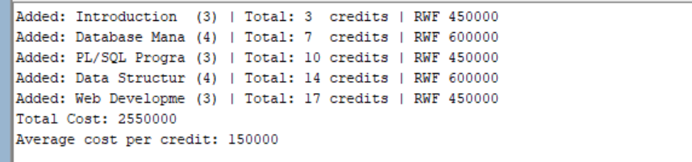
E2: Query
SET SERVEROUTPUT ON

DECLARE
depart varchar(100) := 'Computer Science';
total_salary number :=0;
total_emp number :=0;
higher_earners number :=0;
low_earners number :=0;
highest_paid number :=0;
highest_paid_name varchar2(100);
v_name employees.first_name%TYPE;
v_last_name employees.last_name%TYPE;
v_salary employees.salary%TYPE;
avg_salary number;
cursor emp_list is
select first_name, last_name,salary
from employees where department=depart;

begin

open emp_list;
fetch emp_list into v_name,v_last_name, v_salary;
while emp_list%found loop
total_emp :=total_emp + 1;
total_salary :=total_salary + v_salary;
if v_salary > highest_paid then
highest_paid := v_salary;
highest_paid_name := v_name||' '||v_last_name;
end if;
if v_salary > 75000 then
higher_earners := higher_earners + 1;
elsif v_salary < 65000 then
low_earners := low_earners + 1;
end if;
fetch emp_list into v_name,v_last_name, v_salary;
end loop;
close emp_list;
avg_salary := total_salary / total_emp;
dbms_output.put_line('==== '||depart||' Salary Report ====');
dbms_output.put_line('Total Employees: '||total_emp);
dbms_output.put_line('Total Salary Bill: RWF '||total_salary);
dbms_output.put_line('Average Salary: RWF '||avg_salary);
dbms_output.put_line('Higher Earners (>75k): '||higher_earners);
dbms_output.put_line('Low Earners (<65k): '||low_earners);
dbms_output.put_line('Highest Paid: '||highest_paid_name||' - RWF '||highest_paid);
dbms_output.put_line('========================================');
end;
/

Output
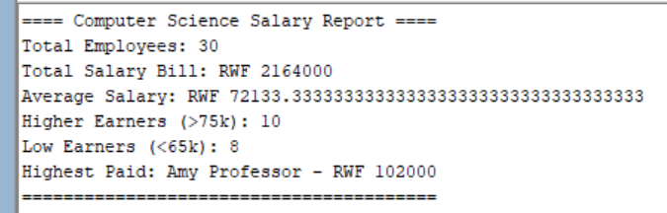

E3: Query
set serveroutput on

declare

v_id number;
v_name varchar2(100);
v_gpa number;
v_label varchar2(100);
v_load varchar2(100);
v_count number;

v_students_printed number := 0;
v_summa number := 0;
v_magna number := 0;
v_cum number := 0;
v_satisfactory number := 0;
v_probation number := 0;

begin

for v_id in 1001..1010 loop

select first_name||' '||last_name,gpa into v_name,v_gpa
from students where student_id = v_id;

select count(student_id) as total into v_count
from enrollments where student_id = v_id;

v_students_printed := v_students_printed + 1;

case

when v_gpa >= 3.9 then
v_label := 'Summa Cum Laude';
v_summa := v_summa + 1;

when v_gpa >= 3.7 then
v_label := 'Magna Cum Laude';
v_magna := v_magna + 1;

when v_gpa >= 3.5 then
v_label := 'Cum Laude';
v_cum := v_cum + 1;

when v_gpa >= 3.0 then
v_label := 'Satisfactory';
v_satisfactory := v_satisfactory + 1;

else
v_label := 'Probation';
v_probation := v_probation + 1;

end case;

case

when v_count >= 4 then
v_load := 'Full Load';

when v_count >= 2 then
v_load := 'Normal Load';

else
v_load := 'Under-enrolled';

end case;

dbms_output.put_line(
rpad('ID: ' || v_id, 10) || '| ' ||
rpad(v_name, 20) || '| ' ||
rpad('GPA: ' || v_gpa, 10) || '| ' ||
rpad(v_label, 20) || '| ' ||
rpad(v_load, 16)
);

end loop;

dbms_output.put_line('Number of students printed: ' || v_students_printed);
dbms_output.put_line('Summa Cum Laude: ' || v_summa);
dbms_output.put_line('Magna Cum Laude: ' || v_magna);
dbms_output.put_line('Cum Laude: ' || v_cum);
dbms_output.put_line('Satisfactory: ' || v_satisfactory);
dbms_output.put_line('Probation: ' || v_probation);

end;
/

Output
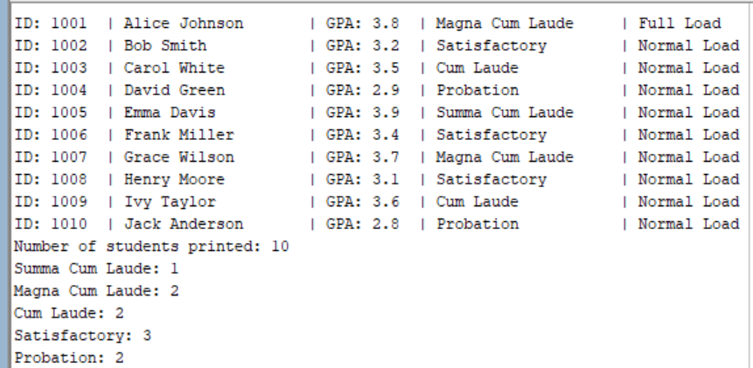

Section F: Combined Challenge

F1: Query
set serveroutput on

declare

emp employees%rowtype;
emp_id number :=5;
hired_year number;
years_of_service number;
service_class varchar(50);
pay_grade number(1);
depart varchar2(100);
count_colleagues number :=0;
highest_salary number;
count_more_earners number :=0;
proposed_salary number;
raise_status varchar2(50);

begin
select * into emp from employees where employee_id = emp_id;

years_of_service :=(months_between(sysdate, emp.hire_date) / 12);

case
when years_of_service >5 then
service_class :='Senior Staff';
when years_of_service >=2 then
service_class :='Confirmed';
else
service_class :='Probationary';
end case;

-- Pay grades: 1 = 100k+, 2 = 90k-99,999, 3 = 80k-89,999,
-- 4 = 70k-79,999, 5 = below 70k

case
when emp.salary >= 100000 then
pay_grade :=1;
when emp.salary >= 90000 then
pay_grade :=2;
when emp.salary >= 80000 then
pay_grade :=3;
when emp.salary >= 70000 then
pay_grade :=4;
else
pay_grade :=5;
end case;

highest_salary :=emp.salary;
for new_emp in (select * from employees where department = emp.department and employee_id != emp.employee_id) loop

count_colleagues :=count_colleagues +1;
if new_emp.salary > highest_salary then
highest_salary := new_emp.salary;
end if;

if new_emp.salary > emp.salary then
count_more_earners := count_more_earners + 1;
end if;

end loop;
dbms_output.put_line('========================================');
dbms_output.put_line(' EMPLOYEE PROFILE REPORT
AUCA Staff Records System');
dbms_output.put_line('========================================');
dbms_output.put_line('Employee: '||emp.first_name||' '||emp.last_name||' (ID: '||emp.employee_id||')');
dbms_output.put_line('Department: '||emp.department);
dbms_output.put_line('Job Title: '||emp.job_title);
dbms_output.put_line('Hire Date: '||emp.hire_date||' | Years of Service: '||to_char(years_of_service, 'fm0.0'));
dbms_output.put_line('Service Status: '||service_class);
dbms_output.put_line('----------------------------------------');
dbms_output.put_line('Salary: RWF '||TO_CHAR(emp.salary, '999,999')||' | Pay Grade: '||pay_grade);
if years_of_service > 3 and emp.salary <85000 then
proposed_salary := emp.salary * 1.10;
raise_status:='Raise recommended';
dbms_output.put_line('Raise Status: '||raise_status);
dbms_output.put_line('Proposed Salary: RWF '||TO_CHAR(proposed_salary, '999,999'));
else
raise_status:='No raise due';
dbms_output.put_line('Raise Status: '||raise_status);
end if;
dbms_output.put_line('----------------------------------------');
dbms_output.put_line('Dept. Colleagues: '||count_colleagues);
dbms_output.put_line('Dept Highest Salary: RWF '||TO_CHAR(highest_salary, '999,999'));
dbms_output.put_line('Colleagues Earning More: '||count_more_earners);
dbms_output.put_line('========================================');

end;
/

Output
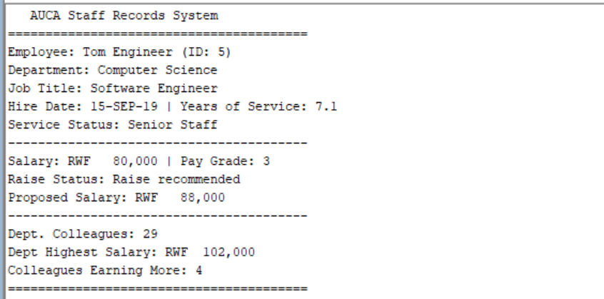

Section G: SQL
G1: Query

WITH stats AS (
SELECT
COUNT(*) AS total_employees,
SUM(salary) AS total_salary,
AVG(salary) AS average_salary,
SUM(CASE WHEN salary > 75000 THEN 1 ELSE 0 END) AS higher_earners,
SUM(CASE WHEN salary < 65000 THEN 1 ELSE 0 END) AS lower_earners,
MAX(salary) AS highest_paid
FROM employees
WHERE department = 'Computer Science'
),
top_employee AS (
SELECT
first_name || ' ' || last_name AS highest_paid_name,
salary
FROM employees
WHERE department = 'Computer Science'
ORDER BY salary DESC
FETCH FIRST 1 ROW ONLY
)
SELECT
stats.total_employees,
stats.total_salary,
stats.average_salary,
stats.higher_earners,
stats.lower_earners,
stats.highest_paid,
top_employee.highest_paid_name
FROM stats
CROSS JOIN top_employee;

Output
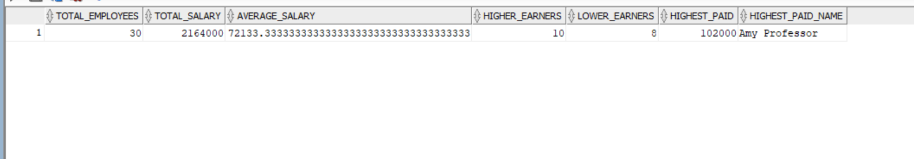

Comparison of E2 and G1 Output
E2: PL/SQL | G1: SQL

Approach I would use
So between SQL and PL/SQL, I would use PL/SQL approach, because it is more flexible for me, because with PL/SQL I can declare separate variables and later i do query to select data I want into variables, and later I make decision based on those variables.

